Session 5 – Drawing with Scratch

Oops, last week I said variables was the last type of function we had not looked at. Actually it is “Pen” operations. You can use pen commands to have your sprites draw things or draw things yourself.

**Step 1: Drawing with the mouse**

Let’s make a “follow the mouse” drawing. We’re going to use keyboard events to control the drawing. Add the following programs to Scratchy’s Scripts. “c” will clear the screen. “s” will leave a copy of the current costume on the screen, and z will draw on the screen. Play around a little with the pen shade and pen size commands to see what they do.

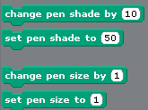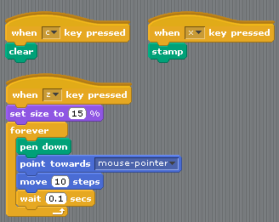

**Step 2: Making shapes**

Scratch can be used to draw shapes on the screen, try these two.

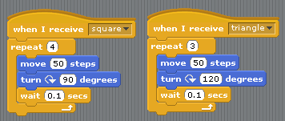

Question: Can you make one that draws a pentagon? The angle you need to turn is 360/n where n is number of sides.

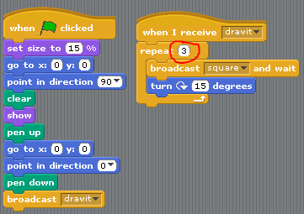**Step 4: Cool stuff with shapes**

Now try a program that does some more advanced drawings. Change the repeat to a bigger value, how big does it need to be to make it all the way around?

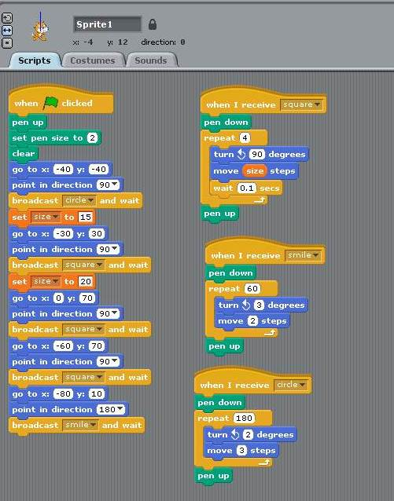**Step 5: More drawing**

You can draw pictures in scratch. I have the script below that I used to draw a happy face. In the main script (the one with ‘When Clicked’), I move to different locations on the stage and broadcast events that draw different types of shapes. Notice that I used a variable size so that I could easily draw different size squares!

**Step 6: A drawing game**

Now we are going to create a game that uses drawing. Start a new scratch project and add the following scripts to Scratchie. Check the <-> box on Scratchie to make sure he doesn’t rotate. Create two variables: falldown and gravity. If you run the game now Scratchie will just run back and forth on the bottom of the screen.

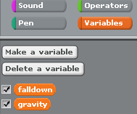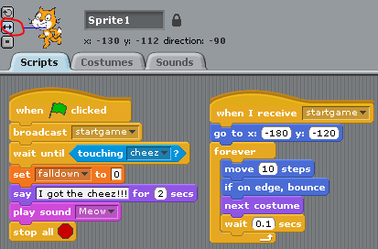

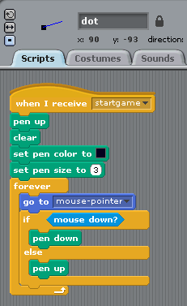**Step 6: Drawing on the screen**

Create a new sprite called “dot” which we will use to draw on the screen. You can import a sprite or draw a small sprite to use. This only works when you are in fullscreen mode! Try running this and see what happens when you press the mouse button down and drag it.

**Step 7: Add Cheese**

Add another sprite in the top right corner of the screen. This is what Scratchie will try to catch. We used cheese puffs, Scratchies favorite snack!

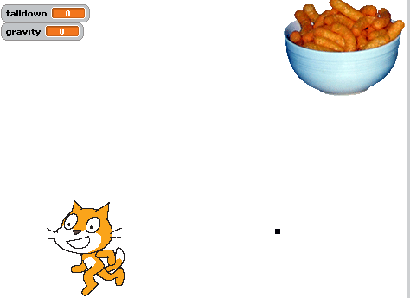

**Step 8: Gravity**

Not we will allow Scratchie to jump up to get the cheese. Use the “up arrow” to make Scratchie jump up to get the cheese. Scratchie will fall to the ground or to lines you draw on the screen.

